Using EZ tools software:
- Go to site type NVR IP address on the browser
- IP address is : 192.168.1.8
- 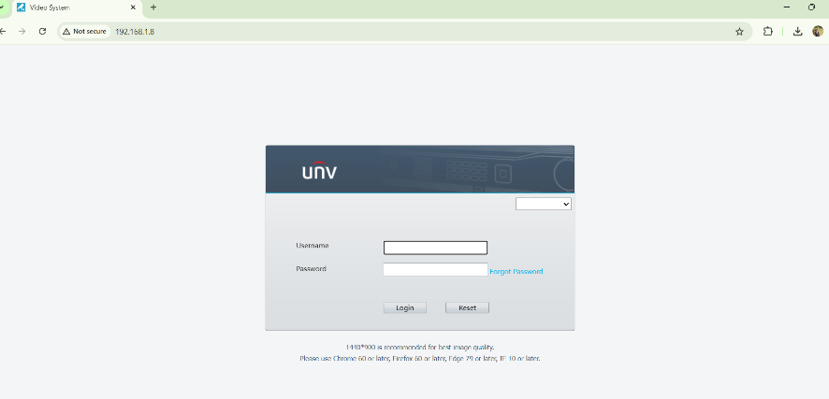
- Type user name and password:
- User name: admin
- password: admin@123
- 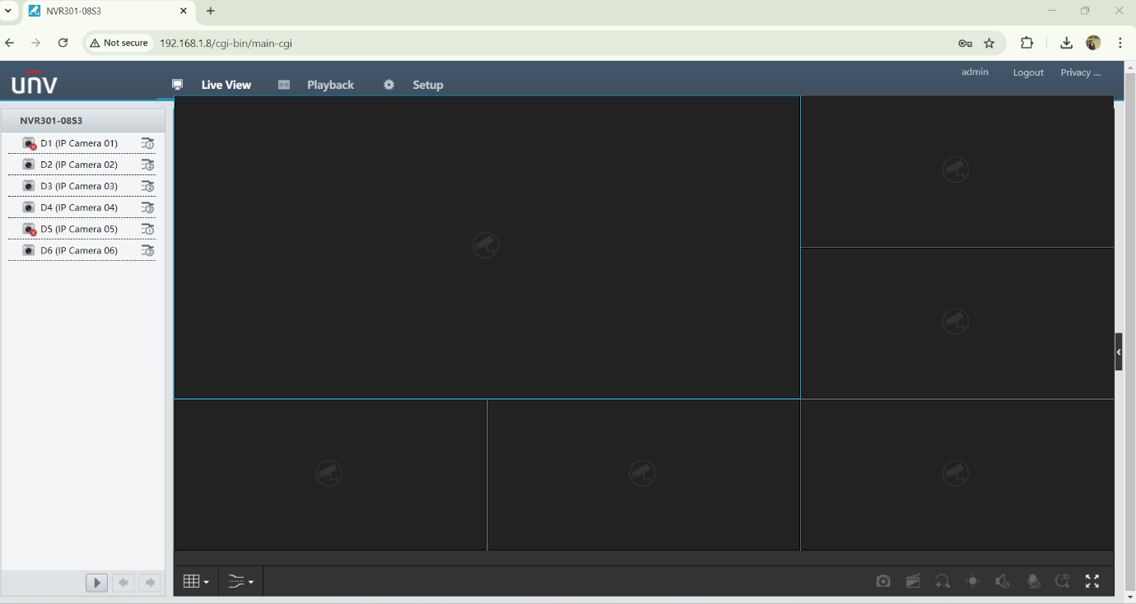
- After clicking on the camera screen will look like
- 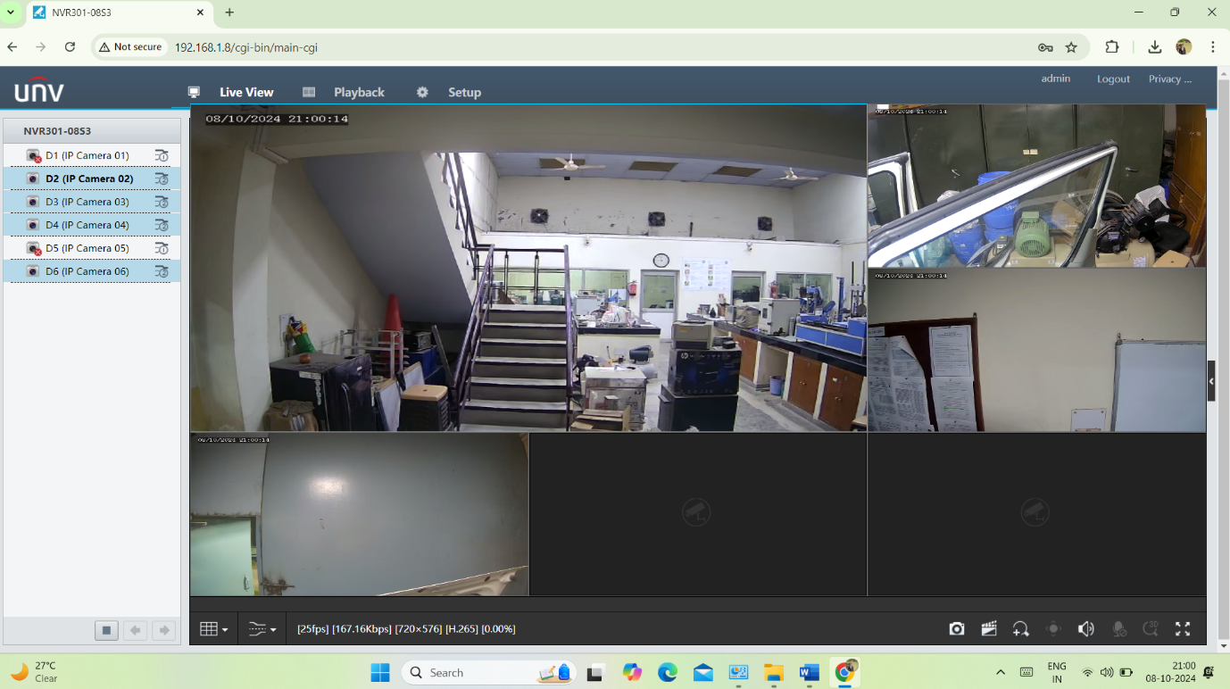
- For synchronization with pc go in to setup
- 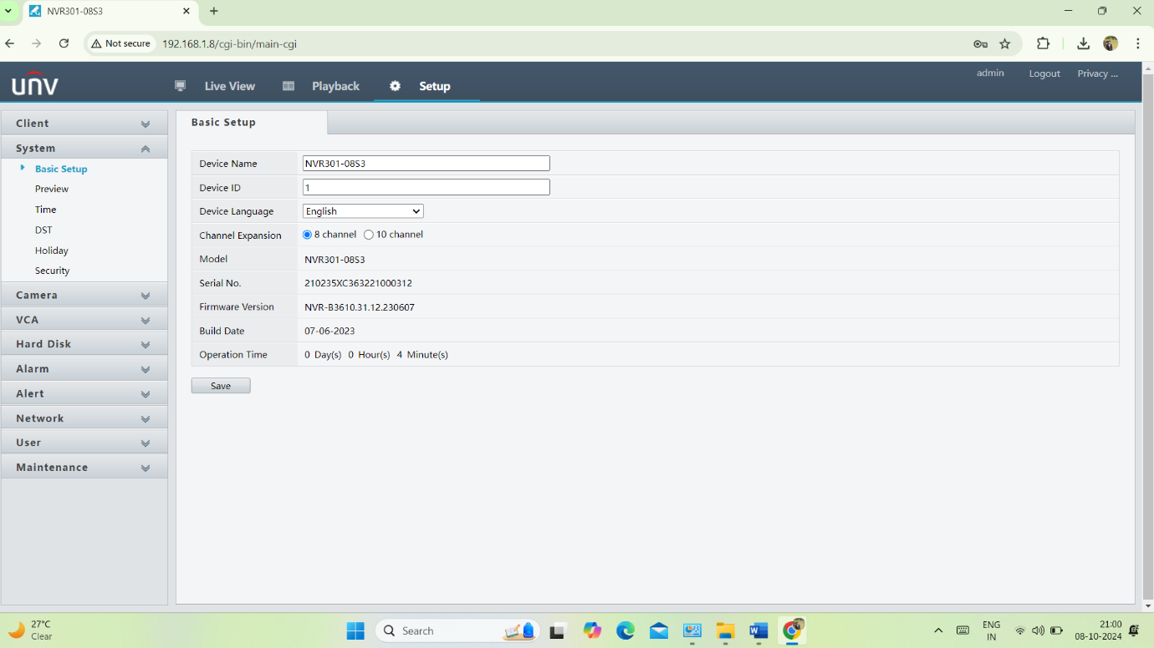
- Then go to time sync with pc
- 
 